Lesson2: Quiz

CS544 Enterprise Architecture

1. Give two things that change when @Id is moved from a field to a getter method:
   1. Reflection -> Setter/getter
   2. All other annotations has to be on getter by default unless @Access to change
2. What SQL datatype do you get when you do not add @Temporal on a java.util.Date field:

Timestamp

1. Annotate the class to make it can be automatically mapped to the table below

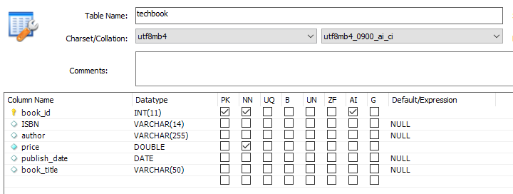

|  |  |
| --- | --- |
| **public class** Book {    **private** Integer **id**;   **private** String **title**;   **private** String **ISBN**;   **private** String **author**;   **private double price**;   **private** Date **publish_date**; | Your Answer: |